
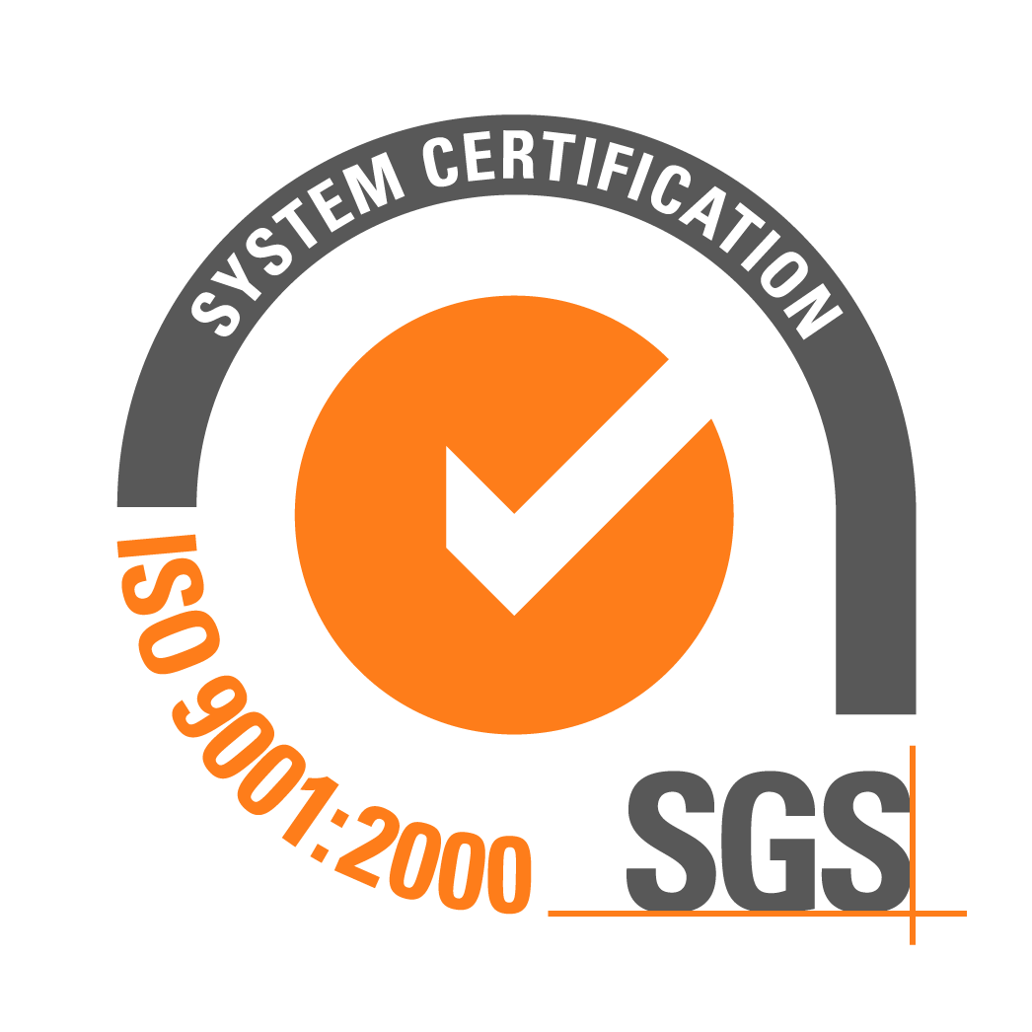

Tel/fax: (048) 746-79-98, 746-91-03
Str. Ilfa and Petrova, 20A, Odessa, 65104, Ukraine

The enterprise “Ukrgazifikatsia-Yug” offers high-quality polyethylene gas pipes of own manufacture, agreeable to the international standards. Pipes are intended for construction and repair of networks of gas supply.

PE80 Gas Pipes according to DSTU B V.2.7-73-98
Outside diameter, mm | SDR – 17,6 |  |  |  | SDR - 11
Outside diameter, mm | MAXIMUM GAS WORKING PRESSURE, MPa
Outside diameter, mm | 0,3 MPa |  |  |  | 0,6 MPa
Outside diameter, mm | Wall thickness | Weight  1 m/r | Price, $ |  |  | Wall thickness | Weight  1 m/r | Price, $
25 | --- | --- | --- |  |  | 3,0 | 0,209 | 0,736
32 | --- | --- | --- |  |  | 3,0 | 0,276 | 0,994
40 | --- | --- | --- |  |  | 3,7 | 0,427 | 1,572
50 | 2,9 | 0,443 | 1,59 |  |  | 4,6 | 0,663 | 2,386
63 | 3,6 | 0,691 | 2,49 |  |  | 5,8 | 1,050 | 3,78
75 | 4,3 | 0,970 | 3,49 |  |  | 6,8 | 1,462 | 5,264
90 | 5,2 | 1,400 | 5,04 |  |  | 8,2 | 2,120 | 7,792
110 | 6,3 | 2,070 | 7,45 |  |  | 10,0 | 3,140 | 11,384
160 | 9,1 | 4,340 | 15,62 |  |  | 14,6 | 6,700 | 24,12
225 | 12,8 | 8,550 | 30,78 |  |  | 20,5 | 13,200 | 47,52
315 | 18,7 | 17,800 | 60,48 |  |  | 28,6 | 25,100 | 96,36
400 | 22,8 | 27,000 | 97,20 |  |  | 36,4 | 41,800 | 153,82
Pipe color: black with yellow stripes, yellow

PE100 Gas Pipes according to TU U V.2.7-21547843.004-2000
Outside  diameter, mm | SDR – 9 |  |  | SDR - 11 |  |  |  | SDR – 17
Outside  diameter, mm | MAXIMUM GAS WORKING PRESSURE, MPa
Outside  diameter, mm | 1,2 МPa |  |  |  | 1,0 МPa |  |  |  | 0,6 МPa
Outside  diameter, mm | Wall thickness | Weight  1 m/r | Price, $ |  | Wall thickness | Weight  1 m/r | Price, $ |  | Wall thickness | Weight  1 m/r | Price, $
63 | 7,1 | 1,520 | 5,54 |  | 5,8 | 1,050 | 3,83 |  | --- | --- | ---
75 | 8,4 | 2,110 | 7,69 |  | 6,8 | 1,462 | 5,33 |  | --- | --- | ----
90 | 10,1 | 3,060 | 11,15 |  | 8,2 | 2,120 | 7,72 |  | 5,4 | 1,460 | 5,32
110 | 12,3 | 4,540 | 16,54 |  | 10,0 | 3,140 | 11,44 |  | 6,6 | 2,120 | 7,84
160 | 17,9 | 9,550 | 34,80 |  | 14,6 | 6,700 | 24,41 |  | 9,5 | 4,420 | 16,10
225 | 25,2 | 18,900 | 68,86 |  | 20,5 | 13,200 | 48,10 |  | 13,4 | 8,630 | 31,44
315 | 35,2 | 35,940 | 130,95 |  | 28,6 | 25,100 | 91,45 |  | 18,7 | 16,920 | 61,65
Pipe color: orange, black with orange stripes

Pipes have passed certification in institute of electric welding by E.O.Paton

of the National Academy Of Sciences of Ukraine.

WE INVITe to cooperation!
The flexible system of discounts is given to wholesale buyers

Str. Ilfa and Petrova, Odessa, 65104, Ukraine, E-mail: ukrgazifikatsia_yug@ua.fm, ukrgaz_yug@te.net.ua
Web-page: http://www.trubype.com.ua Тел./факс: (048) 746-79-98 Тел.: (048) 746-91-03

Settlement account 2600531331 UkrGasBank in Odessa, MFO 328588, Code EDRPOU 20972455

